This is to certify that:
Your Name

Has completed
HIPAA 2020 Refresher Training

on

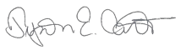
December 30, 2019

Date of Completion Tyson Carter, Manager of Client Education

